Welcome!
Date
Name
Spouse
Address
City
State Zip _________
Email

Please Contact By
❑ Card  Phone  Visit

Telephone Best Time to Call
Home ______________
Work ______________

Guest: First Time Second Time
Are you a church member: yes no
Church
City, State

Circle Appropriate Age/Grade Group(s)
Preschool: Ages: B-1 2-3 4-5
Children: Grades: K 1 2 3 4 5 6
Youth: Grades: 7 8 9 10 11 12
Adults: Ages:18-29 30s 40s 50s 60s+

How did you learn about our church?
Newspaper Friend Yellow Pages Mail
Other

I am a guest of:

New in the Community? Yes No
Names & ages of children at home

Weekly Service & Activity Schedule

July 26, 2015

9:45 a.m. Sunday School
11:00 a.m. Worship Service
6:00 p.m. VBS BEGINS!!!!!

Week of July 26, 2015

No Adult Bible Study Wednesday

Upcoming Events
August
9………………………….…………………Business Meeting
13……………………………………..……..Adult Fellowship
13………………...Birthday Party at Elgin Nursing Home
27……………………………………………Adult Fellowship
30………..…………Baby Shower for Ashley Smothermon


Starting tonight!!

Spread the word!!!

Psalm 30:21 says, “And your ears shall hear a word behind you, saying, “This is the way, walk in it,…” Come join us as we take that “Journey off the Map”

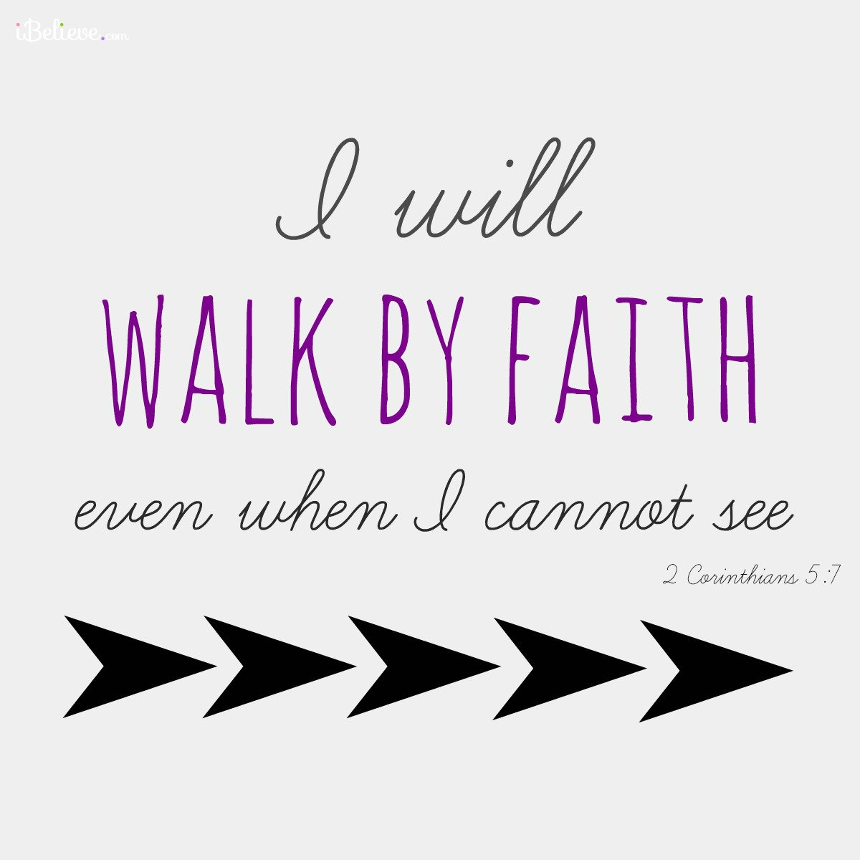

Knobbs Springs Baptist Church

July 26, 2015

Church Information:

KnobbsSpringsBC.com KnobbsSpringsBaptist@gmail.com
1662 CR 305, McDade, Texas 78650 512-273-2743

David Atwood, Pastor Cell 512-470-5098
Home 512-856-2819
Patti Radford, Office Manager Cell 512-968-7821

